PROGRAMMING FUNDAMENTALS
FAROOQ AHMAD
17L-4407
LAB REPORT #2
EXPERIMENT #2

INTRODUCTION
This lab session was about the introduction of pointers and the dynamic arrays which were needed to be included in our programs to solve the real life problems.
Pointer variable: A variable whose content is an address (i.e., a memory address).
Dynamic Array: An array created during the execution of a program.

OBJECTIVE
The course learning objective of this lab session was to execute the programs by using pointer variables and dynamic arrays. Exercise 2 and Exercise 3 was supposed to be performed for the in lab task.

PROCEDURE
Out of the 3 Exercises, the first Exercise was about dry running the code which was already performed during the theory lecture. So we were left with two exercises, Exercise 2 and Exercise 3.
In Exercise 2 we had to write a function resize() that takes as arguments: a pointer pointing to the array of integers, itssize, and a new_size. New_sizecan be any number greater than 0. This function should change the size of the array. If the new size is greater than the previous one, then insert zeroes in new cells.
In Exercise 3 we had to write a code that merges two arrays. Create two dynamic arrays of sizes size_1 and size_2 respectively. Take input in these arrays from the user. Now create a third array of size (size_1+size_2) and insert all the elements of both arrays in this array. Remove the duplicate elements from this array and resize the array to a smaller size.
Both of the Exercises were performed successfully and codes were submitted in the lab submission.

ISSUES
Issues were faced in Exercise 3 for merging the two arrays “a” and “b” into another array “c”.
As the arrays could not be merged within the lab time, though the rest of the code was unable to be completed.

APPLICATION
Pointers are used to store and manage the addresses of dynamically allocated blocks of memory. And Dynamic Array can be altered during the execution of the program. Compared to static arrays, they can not be altered.

POSTLAB
#include <iostream>
using namespace std;

void ReverseWord(char *p, int len)
{
char temp;
for(int i=0; i<len/2; i++)
{
swap(p[i],p[len-i-1]);
}
}

int getlength(char input[],int size)
{
int count = 0;
for(int i=0; input[i]!='\0'; i++,count++);
return count;
}

void main()
{
cout<<"Enter the sentence ... "<<endl;
char input[100];
cin.getline(input,100);

int length = getlength(input,100);

char *q=input;
cout<<"The altered sentence is ..."<<endl;
ReverseWord(q,length);
cout<<input<<endl;
}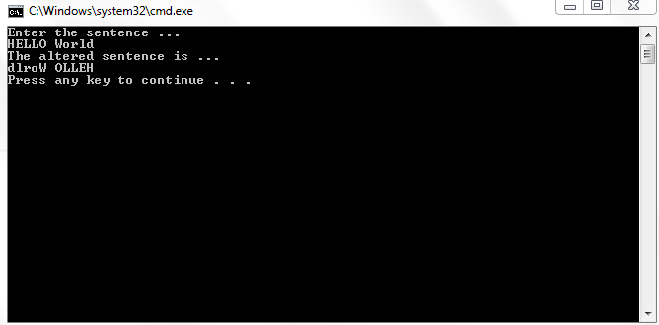

CONCLUSION
After this lab session I was able to use pointer variable and dynamic arrays in my programmes.
Exercise 1 and 2 were successfully executed but Exercise 3 was partially solved but not fully executed due issues faced.

